**COMP 4620 Web-Based Information Systems**

**Seminar/Lab 9**

**MongoDB Web Service**

1. **Objectives**

* Understand how REST works
* Use REST

1. **MongoDB Web Service**
   1. server.js and model.js

* You need to implement the next four operations in server.js using the functions in model.js.
  + SignUp
  + Unsubscribe
  + SignIn/Open
  + SignOut/Close
* If you do not use the RESTful API that we have used in the classes, the next app would not work properly.
* You need to use your port number

1. **How to test?**
   1. Run **server.js**.
   2. Open <http://cs.tru.ca/~mlee/comp4620/Winter2022/9.%20Seminars/w11_truwebservice.html> from a web browser, and test the app with your port number.

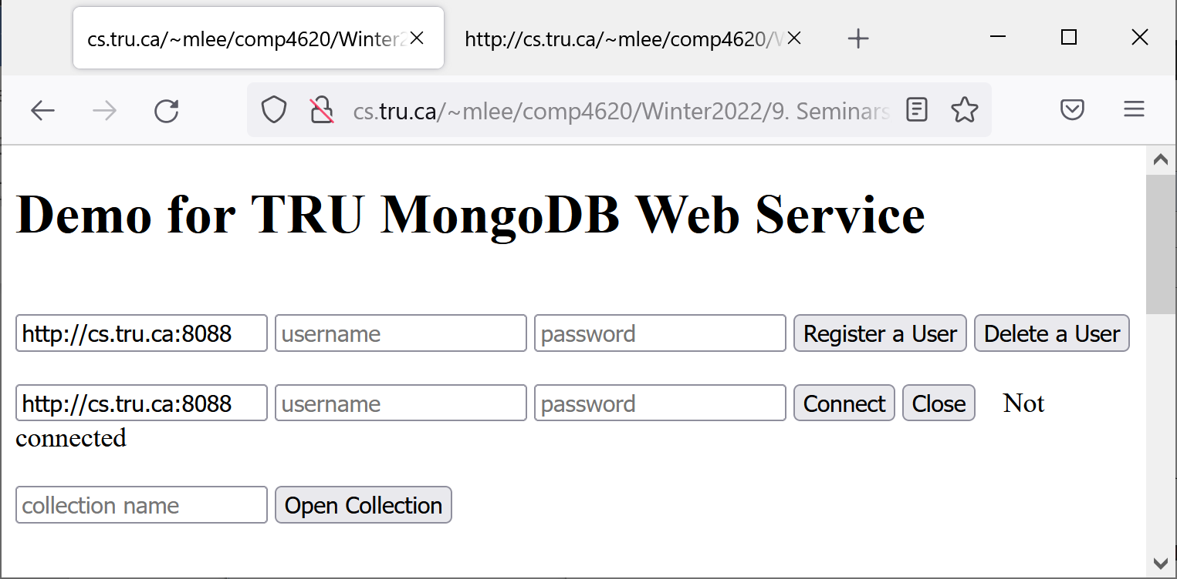

1. **How to keep running ‘node’ when you logout?**
   1. You need to run your Node web server using the ‘nohup’ command so that your web server can be tested later. For example,

$ nohup node ….js &

* 1. How to kill the above node process later?
* Find your process. E.g., $ ps -aef | grep node
* $ kill -p *process_number*

1. **Assignment**
   1. Submission

* Keep server.js in 2) running, and submit your WebService port number
* Total marks: 10
* Due:
  + 11:59 PM, March 31, 2022 – 10% bonus
  + 11:59 PM , April 4, 2022 – full marks
  + 11:59 PM, April 5, 2022 – 10% penalty
* Any late submission will not be accepted.
* You should not update the application after you submitted. The information of any update of a file/directory will be left on CS, and I can check the last update date and time.
* The evaluation will be usually one of pass, half-pass, and fail. Most incomplete applications will get fail.